HOMEWORK PROBLEM

a. Given the expressions for strains in terms of stress,

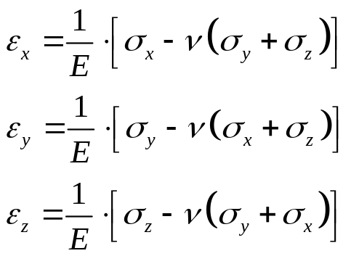

Derive the expressions for stress in terms of strains.

b. Derive the expression for the strain in terms of stress for the cases of plane stress (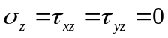) and plane strain (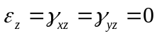).

c. Derive the expression for the stress in terms of strain for the cases of plane stress () and plane strain () .

